5.1 Work Breakdown Structure chart:

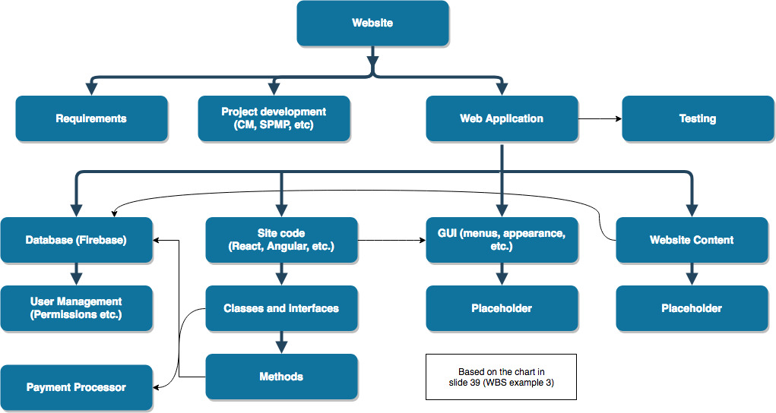

5.2 Dependencies between tasks:

Requirements must be complete and up-to-date before any relevant work on the Web Application or Project Documentation is done.

The database and domain must be set up before any other part can be tested.

Depending on the test case, certain parts of the GUI might be unusable without website content. So we must create some website content for the purpose of test cases.

The classes and methods must be complete and tested before the GUI is established.

Obviously, testing requires a section of the Web Application to be completed to a level necessary for the test.